Wound Management Expo

The wound management team at the THS South has introduced the grand round as a learning opportunity. A part of this initiative is the wound management/product expo.

Invitation is extended to all interested nursing, allied health and medical staff to attend this inaugural event. Supported by national and international trade companies the expo will be held twice a year and presents opportunity to browse products, network and learn about the varied lines available in the market place.

This is not limited to products that are on the current DHHS tender.

Friday March 31 st 2017

Hotel Grand Chancellor
Davey Street, Hobart

Session 1 11:00 – 13:30
Casual browsing of trade displays. Designed for
before work or lunchtime visit

Session 2 16:30 – 19:00
Includes 2 presentations
Further info to follow

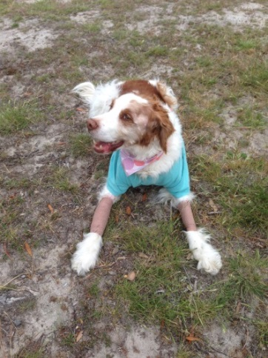
There will be some refreshments and light snacks served during both sessions.

THIS IS A FREE EVENT
